My Target: /25 or %

Score:
/25

Unit 2 Modern History
Understanding the Modern World

SOURCE ANALYSIS ONE
Nazism in Germany 1918-1945

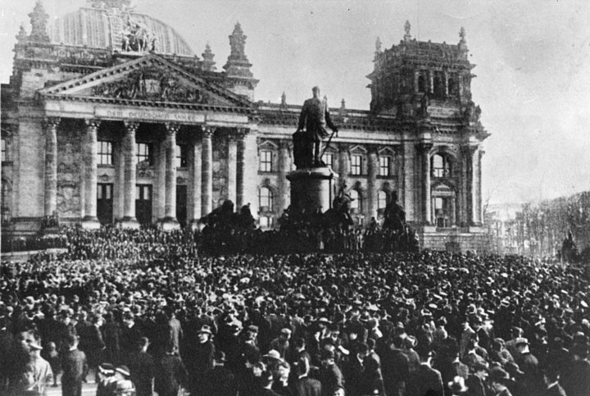

Name: _______________________ Date:

Weighting - 10 %

- Compare and contrast the messages of Sources 1 and 2. (4 marks) ____________________________________________________________________________________________________________________________________________________________________________________________________________________________________________________________________________________________________________________________________________________________________________________________________________________________________________________________________________________________________________________________________________________________________________________________________________________________________________________________________________________________________________________________________________________________________________________________________________________________________________________________________________________________________________________________________________________________________________________________________________________________________________________________________________

- Evaluate the usefulness, in terms of strengths and weaknesses, of Sources 1 and 2 as representations of attitudes in post-war Germany. (5 marks) ____________________________________________________________________________________________________________________________________________________________________________________________________________________________________________________________________________________________________________________________________________________________________________________________________________________________________________________________________________________________________________________________________________________________________________________________________________________________________________________________________________________________________________________________________________________________________________________________________________________________________________________________________________________________________________________________________________________________________________________________________________________________________________________________________________________________________________________________________________________________________________________________________________________________________________________________________________________________________________________________________________________________________________________________________________________________________________________________________________________________________________________________________________________________________________________________________________________________________________________________________________________________

- Explain the historical context of Source 3. Include the relevant events, people and ideas depicted or represented in the source. (4 marks) ________________________________________________________________________________________________________________________________________________________________________________________________________________________________________________________________________________________________________________________________________________________________________________________________________________________________________________________________________________________________________________________________________________________________________________________________________________________________________________________________________________________________________________________________________________________________________________________________________________________________________________________________________________________________________________________________________________________________________________________________________________________________________________________________________________________________________________________________________________________________________________________________________________________________________________________________________________________________________________________________________________________________________________________________________________________________________________________________________________________________________________________________________________________________________________________________________________________________________________________________________________________________________________________________________________________________________________________________________________________________________________

- Identify and account for the authors’ perspectives in Sources 3 and 4 regarding the specific changes in post-war German politics described in the documents. (6 marks)

____________________________________________________________________________________________________________________________________________________________________________________________________________________________________________________________________________________________________________________________________________________________________________________________________________________________________________________________________________________________________________________________________________________________________________________________________________________________________________________________________________________________________________________________________________________________________________________________________________________________________________________________________________________________________________________________________________________________________________________________________________________________________________________________________________________________________________________________________________________________________________________________________________________________________________________________________________________________________________________________________________________________________________________________________________________________________________________________________________________________________________________________________________________________________________________________________________________________________________________________________________________________

- Evaluate the extent to which the four sources give an accurate insight into the significant changes occurring in post-war Germany between 1918 and 1922. (6 marks) ____________________________________________________________________________________________________________________________________________________________________________________________________________________________________________________________________________________________________________________________________________________________________________________________________________________________________________________________________________________________________________________________________________________________________________________________________________________________________________________________________________________________________________________________________________________________________________________________________________________________________________________________________________________________________________________________________________________________________________________________________________________________________________________________________________________________________________________________________________________________________________________________________________________________________________________________________________________________________________________________________________________________________________________________________________________________________________________________________________________________________________________________________________________________________________________________________________________________________________________________________________________________

End of Questions

